BLOCKCHAIN VOTING SYSTEM

**S.Vairachilai, Naman Mishra, Akshat Agrawal, Suman Bhandari**

School of Computing Science and Engineering,

VIT Bhopal University, Madhya Pradesh - 466114

***Abstract*-** The blockchain technology has the potential to revolutionize the way we conduct elections by providing a secure and transparent mechanism for recording and counting votes. The blockchain voting system uses a decentralized and tamper-proof ledger to record votes, ensuring that the results are verifiable and transparent. This paper presents an overview of the blockchain voting system, including its advantages, limitations, and potential challenges. The analysis shows that the blockchain voting system can provide a secure, transparent, and efficient mechanism for conducting elections, but further research and testing are necessary to ensure its accessibility, security, and trustworthiness. Overall, the blockchain voting system offers a promising solution to the challenges of traditional voting systems and could become a game-changer in the way we conduct democratic processes.

Keywords: - Blockchain Technologies, Electronic Voting, Voting Machines, Cybersecurity

INTRODUCTION

Voting is a critical process in democratic societies, allowing citizens to participate in the selection of their leaders and decision-making. However, traditional voting systems have several limitations, such as the potential for fraud, voter intimidation, ballot stuffing, and other vulnerabilities that can compromise the integrity of the electoral process. The use of blockchain technology in the development of a secure and transparent voting system offers a potential solution to these challenges.

The blockchain is a decentralized and tamper-proof ledger that records transactions in a secure and transparent manner. The technology has gained significant attention in recent years due to its potential applications in various domains, including finance, healthcare, and supply chain management. In the context of voting, the blockchain technology promises to provide a secure and transparent mechanism for recording and counting votes, ensuring that the results are verifiable and tamper-proof.

The blockchain voting system operates by recording each vote on a decentralized and tamper-proof ledger, making it impossible to alter or manipulate the results. The system eliminates the need for intermediaries and provides a secure and private mechanism for casting votes. The use of blockchain technology in the voting process can address the concerns of traditional voting systems and provide a more secure, transparent, and efficient mechanism for conducting elections.

This paper presents a comprehensive analysis of the blockchain voting system, including its advantages, limitations, and potential challenges. The analysis examines the potential benefits of the blockchain voting system, including its transparency, security, and efficiency. It also highlights the potential challenges and limitations of the system, such as its complexity and technical requirements, potential cyber attacks, and the need to address privacy and anonymity concerns.

Overall, the use of blockchain technology in the development of a voting system offers a promising solution to the challenges of traditional voting systems. With further research, development, and testing, the blockchain voting system could become a game-changer in the way we conduct elections, providing a more reliable and democratic mechanism for recording and counting votes.

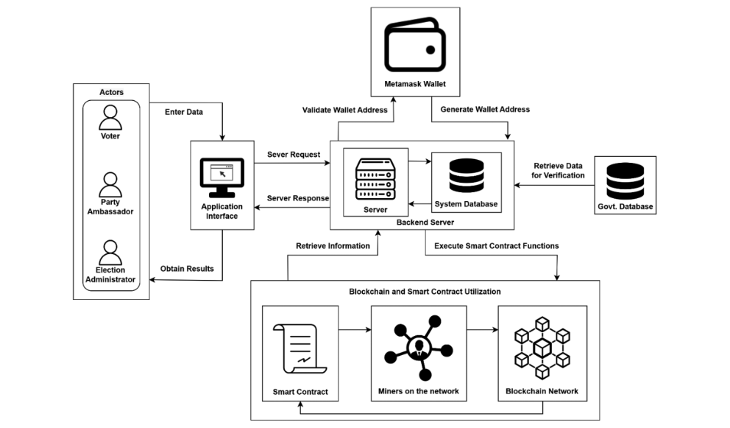

Ahmed Ben Ayed [2017] : He proposed an electronic voting system based on the Blockchain technology. The system is decentralized and does not rely on trust. Any registered voter will have the ability to vote using any device connected to the Internet. The Blockchain will be publicly verifiable and distributed in a way that no one will be able to corrupt it. We as well illustrated the limitations with our system, which will be addressed in future research papers.

Francesco Fusco[2018] : This paper describes the research proposal to define and implement a new e-voting system concept. This system is called Crypto-voting and it is based on permissioned blockchain technology.The elements of innovation, compared to the state of the art, consist in the approach, in the technology and smart contract.

[Maria-Victoria Vladucu](https://ieeexplore.ieee.org/author/37089755982)[2023]: This survey gives a review of traditional, electronic, and blockchain electronic voting systems. It categorizes terminologies used in the introduction and implementation of blockchain e-voting systems including consensus algorithms, frameworks, performance evaluation, characteristics for a successful system, cryptography, and tools to implement such systems.

Mustafizur Rahaman[2023]: voters do not have to pay any gas fees while submitting their vote; instead, the reward incentive mechanism assists in increasing the number of overall election turnouts, and the solution has been completely done without using any external token service like the ERC20 token.

Gautham Srivastav, Mhd.Baza[2022] : Experiments were set up to evaluate the performance of the proposed system, and an analysis of the results revealed that the current scheme is practical for both small and mid-sized elections where low latency is desired. Additionally, no matter the size of the workload, the Ethereum network is able to maintain a 0% error rate when executing the system’s transactions, proving that, if deployed on the Ethereum network, our system has extremely high reliability.

[Adel Khelifi](https://ieeexplore.ieee.org/author/37089048918)[2022] : The proposed system is a secure, transparent, and reliable platform for the authorities, and voters. The proposed framework has a promising output based on the performance evaluation of blockchain technology in VMS.

[Dylan Weiss](https://ieeexplore.ieee.org/author/37089710790)[2022]: This system fulfills the essential requirements of e-voting systems which includes: no coerce to voters, no traceability of voters’ identity, the assurance and proof of vote, no one could change the casted votes, the counting of votes and election result must be decentralized, security and integrity of ballot to cast individual votes.

R. Hansarandi Adithya Rathnayake[2022] : The goal of the design and testing of the proposed electronic voting system was to determine the viability of a decentralized solution capable of satisfying the most stringent criteria of both public settings and private corporate consortiums. Based on preliminary findings, it was evident that blockchain met the requirements for electronic voting systems. Include openness, consistency, and resiliency.

[Zarina Shukur](https://sciprofiles.com/profile/1107563)[2021] : The blockchain’s potential is fundamental to enhance electronic voting, current solutions for blockchain-based electronic voting, and possible research paths on blockchain-based electronic voting systems. Numerous experts believe that blockchain may be a good fit for a decentralized electronic voting system.Furthermore, all voters and impartial observers may see the voting records kept in these suggested systems. On the other hand, researchers discovered that most publications on blockchain-based electronic voting identified and addressed similar issues.

* ADVANTAGES OF BLOCKCHAIN VOTING SYSTEM:

The blockchain voting system has several advantages over traditional voting systems. Firstly, it offers a transparent and auditable voting process, where every vote is recorded on a decentralized and immutable ledger. This ensures that the vote cannot be tampered with or altered, and the results are verifiable and transparent.

Secondly, the blockchain voting system offers a secure and private voting process, where voters can cast their votes anonymously without the need for intermediaries. This eliminates the possibility of voter intimidation or coercion and ensures that the voter's identity remains confidential.

### SUMMARY OF RELATED WORK

|  |  |  |  |  |
| --- | --- | --- | --- | --- |
| **Author** | **Hashing Algorithm** | **Frame**  **work** | **BC Type** | **link** |

|  |  |  |  |  |
| --- | --- | --- | --- | --- |
| Ahmed Ben Ayed | SSHA256 | Bitcoin | Private/public | <https://www.researchgate.net/profile/Ahmed-Ben-Ayed-4/publication/341498272_A_CONCEPTUAL_SECURE_BLOCKCHAIN-BASED_ELECTRONIC_VOTING_SYSTEM/links/5ec4852a299bf1c09acbe626/A-CONCEPTUAL-SECURE-BLOCKCHAIN-BASED-ELECTRONIC-VOTING-SYSTEM.pdf> |
| Francesco Fusco | Not Specified | Bitcoin and Ethereum | public | <https://www.researchgate.net/profile/Andrea-Pinna-6/publication/327907758_Crypto-voting_a_Blockchain_based_e-Voting_System/links/5cb8de2da6fdcc1d499ef07a/Crypto-voting-a-Blockchain-based-e-Voting-System.pdf> |
| [Maria-Victoria Vladucu](https://ieeexplore.ieee.org/author/37089755982) | Not Specified | Bitcoin and Ethereum | public/private/ hybrid | <https://ieeexplore.ieee.org/abstract/document/10061373> |
| Gautham Srivastav, Mhd.Baza | Not Specified | Ethereum | Private/public | <https://www.mdpi.com/article/10.3390/app13021096> |
| Mustafizur Rahaman | Not Specified | Ethereum | Private | <https://ietresearch.onlinelibrary.wiley.com/doi/full/10.1049/blc2.12021> |
| [Adel Khelifi](https://ieeexplore.ieee.org/author/37089048918) | cryptographic hash | bitcoin | Private | <https://ieeexplore.ieee.org/abstract/document/9787540> |
| [Dylan Weiss](https://ieeexplore.ieee.org/author/37089710790) | Not Specified | Bitcoin and Ethereum | Public | <https://ieeexplore.ieee.org/abstract/document/10025096> |
| R. Hansarandi Adithya Rathnayake | SHA-256 | bitcoin | Private | <https://www.researchgate.net/profile/Hansarandi-Adithya/publication/368282306_Electronic_Voting_System_based_on_Blockchain_for_Sri_Lanka_Conceptual_Overview/links/63df4a1ac97bd76a826c3b60/Electronic-Voting-System-based-on-Blockchain-for-Sri-Lanka-Conceptual-Overview.pdf> |
| [Zarina Shukur](https://sciprofiles.com/profile/1107563) | cryptographic hash | Ethereum | Private/public | <https://www.mdpi.com/1424-8220/21/17/5874> |

LIMITATIONS AND CHALLENGES

Despite the advantages of the blockchain voting system, there are several challenges that need to be addressed. Firstly, the system's complexity and technical requirements may limit its accessibility to some users, especially those who are not tech-savvy or have limited access to technology.

Secondly, the blockchain voting system may be vulnerable to cyber attacks, such as Distributed Denial of Service (DDoS) attacks or 51% attacks, which can compromise the integrity of the system.

Thirdly, the blockchain voting system's anonymity and privacy features may create opportunities for malicious actors to manipulate the system by casting multiple votes or interfering with the voting process.

CONCLUSION

The blockchain voting system is a promising development in the evolution of voting systems, offering a secure, transparent, and tamper-proof mechanism for recording and counting votes. However, the technology's limitations and potential challenges need to be addressed to ensure that the system is accessible, secure, and trustworthy. With further research, development, and testing, the blockchain voting system could become a game-changer in the way we conduct elections, providing a more reliable and democratic mechanism for recording and counting votes.

ACKNOWLEDGMENT

I would like to express my gratitude to the individuals and organizations who have contributed to the development of the blockchain voting system. This innovative technology has the potential to revolutionize the way we conduct elections and ensure greater transparency, security, and accuracy in the process. I would first like to thank the pioneers of blockchain technology who have laid the foundation for this innovative application. Their vision and dedication have paved the way for the creation of new and exciting solutions, including blockchain voting system. I also want to acknowledge the efforts of researchers and developers who have invested countless hours into creating and refining this technology. Their expertise, creativity, and dedication have enabled the development of a secure and transparent system that can be used for voting purposes. In conclusion, the development of the blockchain voting system has been a collaborative effort that involves the contributions of numerous individuals and organizations. I am grateful for their efforts and look forward to the continued advancement of this innovative technology.

REFERENCES

1. <https://www.researchgate.net/profile/Andrea-Pinna-6/publication/327907758_Crypto-voting_a_Blockchain_based_e-Voting_System/links/5cb8de2da6fdcc1d499ef07a/Crypto-voting-a-Blockchain-based-e-Voting-System.pdf>
2. <https://www.researchgate.net/profile/Hansarandi-Adithya/publication/368282306_Electronic_Voting_System_based_on_Blockchain_for_Sri_Lanka_Conceptual_Overview/links/63df4a1ac97bd76a826c3b60/Electronic-Voting-System-based-on-Blockchain-for-Sri-Lanka-Conceptual-Overview.pdf>
3. <https://ieeexplore.ieee.org/abstract/document/9787540>
4. <https://www.mdpi.com/article/10.3390/app13021096>
5. h[ttps://www.researchgate.net/profile/Andrea-Pinna-6/publication/327907758_Crypto-voting_a_Blockchain_based_e-Voting_System/links/5cb8de2da6fdcc1d499ef07a/Crypto-voting-a-Blockchain-based-e-Voting-System.pdf](https://www.researchgate.net/profile/Andrea-Pinna-6/publication/327907758_Crypto-voting_a_Blockchain_based_e-Voting_System/links/5cb8de2da6fdcc1d499ef07a/Crypto-voting-a-Blockchain-based-e-Voting-System.pdf)
6. https://ietresearch.onlinelibrary.wiley.com/share/GXGDRTEDCKZCT7D4N55V?target=10.1049/blc2.12021